Experiment 6: Responder design experiment
After completion of the above experiments that have a lot of friends can independently accomplish the experiment the, this experiment is the touch of a button on control lights of the expanded into three keys corresponding to the three lights, occupy six digital I / O interface.
Circuit connection diagram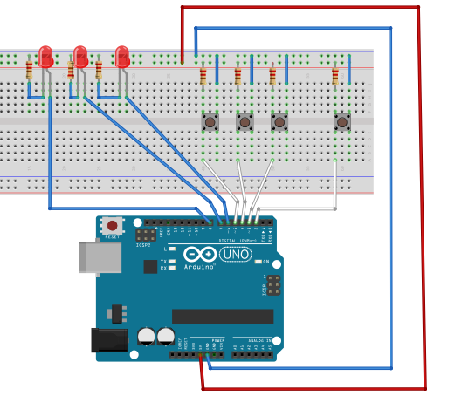
Principle here is not much said with the above experiments, the following is attached to the reference schematic and physical connection diagram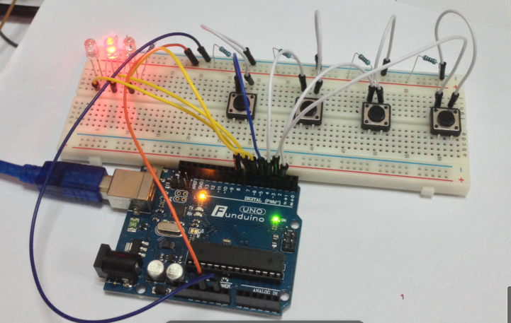
Reference to source program is as follows:
int redled=8; //Red LED output
int yellowled=7; //yellow LED output
int greenled=6; //green LED output
int redpin=5; //Red button pin
int yellowpin=4; //yellow button pin
int greenpin=3; //green button pin
int restpin=2; //Reset pin definition
int red;
int yellow;
int green;
void setup()
{
pinMode(redled,OUTPUT);
pinMode(yellowled,OUTPUT);
pinMode(greenled,OUTPUT);
pinMode(redpin,INPUT);
pinMode(yellowpin,INPUT);
pinMode(greenpin,INPUT);
}
void loop() //Key cycle scan.。
{
red=digitalRead(redpin);
yellow=digitalRead(yellowpin);
green=digitalRead(greenpin);
if(red==LOW)RED_YES();
if(yellow==LOW)YELLOW_YES();
if(green==LOW)GREEN_YES();
}

void RED_YES()//Always perform a red light，Until the reset button is pressed, the end of the loop
{
while(digitalRead(restpin)==1)
{
digitalWrite(redled,HIGH);
digitalWrite(greenled,LOW);
digitalWrite(yellowled,LOW);
}
clear_led();
}
void YELLOW_YES()//Always perform a yellow light，Until the reset button is pressed, the end of the loop
{
while(digitalRead(restpin)==1)
{
digitalWrite(redled,LOW);
digitalWrite(greenled,LOW);
digitalWrite(yellowled,HIGH);
}
clear_led();
}
void GREEN_YES()//Always perform a green light，Until the reset button is pressed, the end of the loop

{
while(digitalRead(restpin)==1)
{
digitalWrite(redled,LOW);
digitalWrite(greenled,HIGH);
digitalWrite(yellowled,LOW);
}
clear_led();
}
void clear_led()//clear LED
{
digitalWrite(redled,LOW);
digitalWrite(greenled,LOW);
digitalWrite(yellowled,LOW);
}
The experimental phenomenon, said the responder, who is certainly the first press, who lit lanterns!
And then press the REST button, reset.
Download program, easy responder designed by ourselves is complete.

